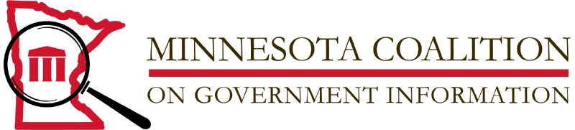

FOR IMMEDIATE RELEASE - March 5, 2008

Freedom of Information Award Recognizes
Bridge Collapse Coverage, Pro se Legal Services

Silha Center’s Jane Kirtley Envisions “The Light at the End of the Tunnel”

The people’s right to know assumes a vast network of agencies and individuals committed to affirmation of that right. Recipients of the 2008 John R. Finnegan Freedom of Information Award reflect the many facets of information access. The Minnesota Coalition on Government Information (MnCOGI) will present this year’s awards as a highlight of Freedom of Information and the kickoff of Sunshine Week 2008.

By any measure, the collapse of the 35W Bridge is the story of 2007 - covered by every news medium from every journalistic angle. Recipients of the FOI Award include several investigative journalists including Associated Press staffers Martiga Lohn and Brian Bakst and Star Tribune reporters Dan Browning, Kevin Diaz, Patrick Doyle, Mike Kaszuba and Paul McEnroe. All of these journalists have enhanced public understanding of the tragedy through their explicit use of the Freedom of Information Act and the Minnesota Data Practices Act to gain access to public information.

The Coalition will also confer two Honorable Mention Awards. An Honorable Mention Award will be given to Susan Albright, former Editorial Page Editor at the Star Tribune. Albright, now with MinnPost, is recognized for her articulate appreciation of the dependence of a free press on access to government information and for her consistent editorial support of the principles of open government.

Recipients of the second Honorable Mention Award are Susan Ledray and Katrina Zabinski, coordinators of the innovative “Self Help Center” (SHC) in Minnesota’s Fourth Judicial District. As designers of the SHC Ledray and Zabinski explicitly used government information to both define and meet the needs of a targeted population. The nomination document notes that the SHC serves “thousands of pro se litigants in Minnesota to move through court more efficiently, more effectively and more informed.” In the words of Judge Edward Lynch, the SHC “provides information, resources and assistance to thousands of litigants representing themselves in court proceedings.” The Self Help Center is now available in all Minnesota counties.

Awards will be presented at Freedom of Information Day ceremonies on Friday, March 14, Noon-1:00 at the Minneapolis Central Library.
Keynote speaker for the event is Jane Kirtley, irector of the Silha Center for the Study of Media Ethics and Law at the University of Minnesota. Kirtley is an internationally-known expert and lecturer on issues of media law and freedom of information. Prior to joining the U of M School of Journalism and Mass Communication in 1999, Kirtley was the Executive Director of the Reporters Committee for Freedom of the Press and a columnist for American Journalism Review. Her presentation is entitled “The Light at the End of the Tunnel: The Outlook for FOI.”
John R. Finnegan, Sr., for whom the award is named, is a Minnesota journalist and renowned defender of the First Amendment and the role of informed citizens in a democracy.

The Minnesota Coalition on Government Information is a nonprofit 501(c)(3) corporation representing individuals and organizations committed to open access to public information in print, electronic and digital formats. The Coalition involves media representatives, attorneys, librarians, computer professionals, state and local government officials, educators and others who care about transparency in government, information access and the role of an informed citizenry in a democracy.

# # #

Contact: Mary Treacy
Minnesota Coalition on Government Information
mncogi@gmail.com
http://www.mncogi.org

